Evaluating Classification Models Performance

Actual is Red

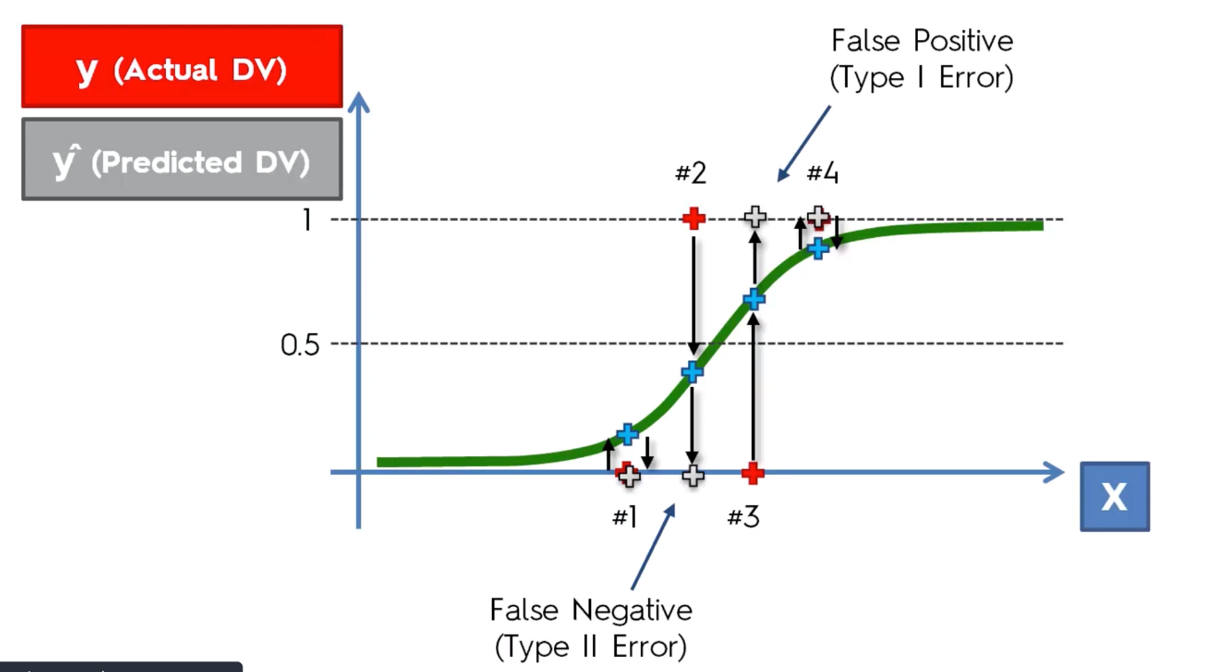Predicted in Grey

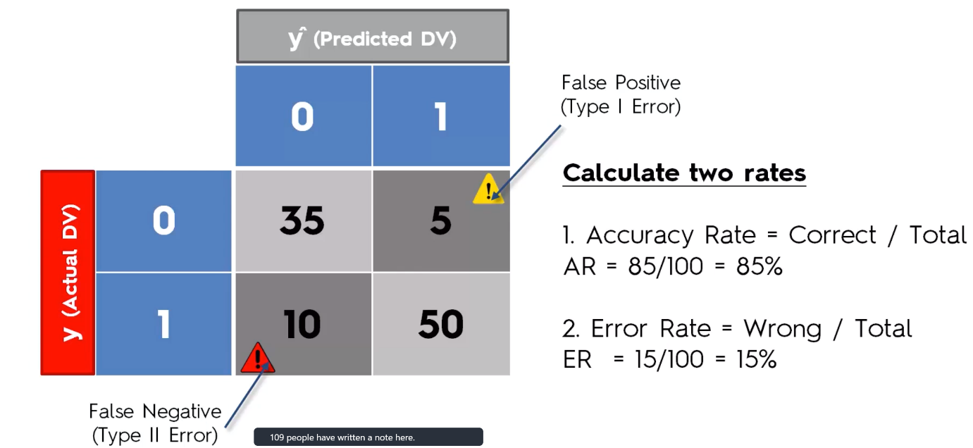Confusion Matrix –

Accuracy Paradox –

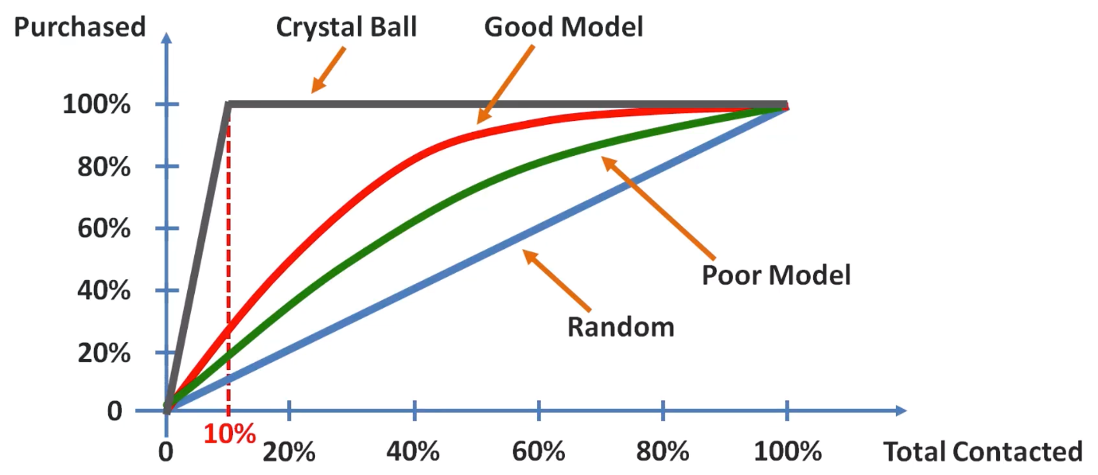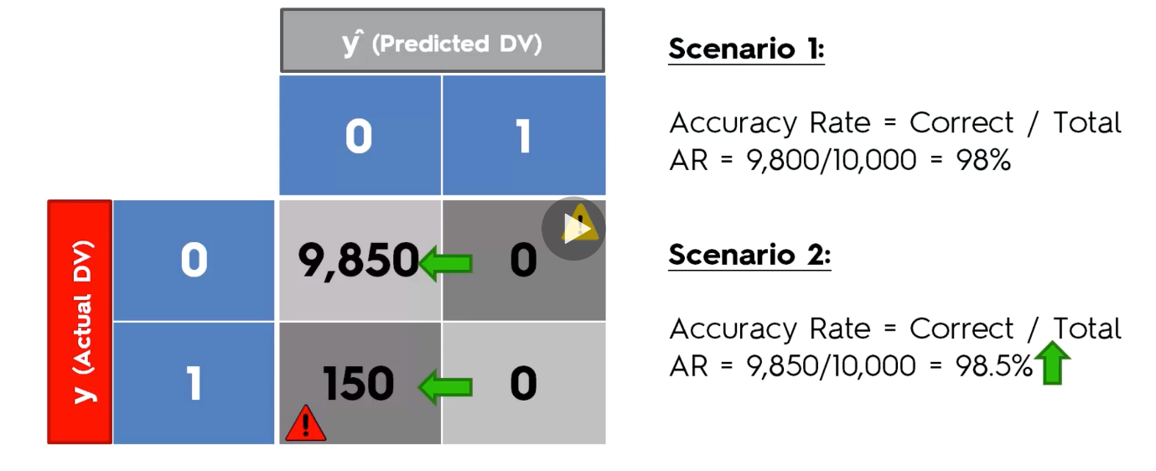CAP Cumulative Accuracy Profiling

CAP – Cumulative Accuracy Profile

ROC - Receiver Operating Characteristic

CAP Curve Analysis- Standard Approach

1. Area under the Perfect Model – a­p
2. 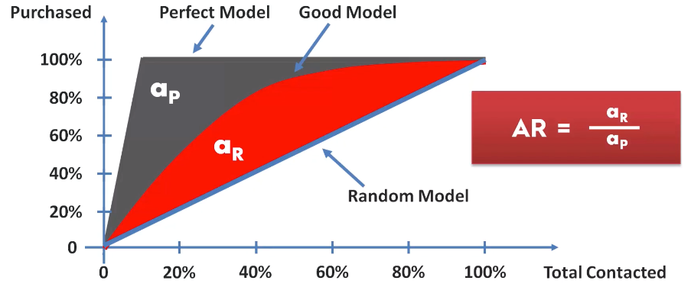Area under the Good Model - aR

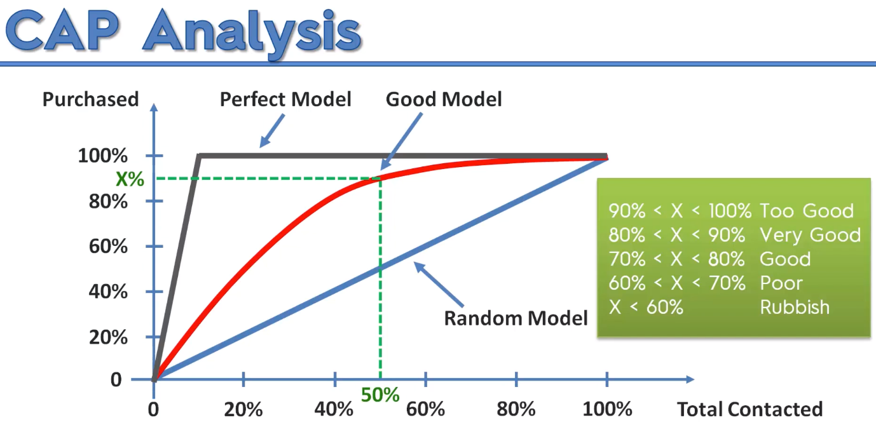Second Approach – Look at 50% line and See whats the Good Model result is.